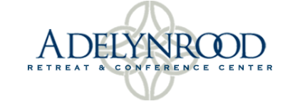

Adelynrood Retreat and Conference Center COVID-19 Protocols
(Updated May 10, 2022)

Adelynrood is committed to the health and safety of our guests, staff, and volunteers. We can protect each other best with these precautions:

- All guests at Adelynrood are required to have received the COVID-19 vaccine and booster shot at least 2 weeks prior to arrival unless they are unable to due to a medical reason. Proof of vaccination and booster shot must be shown upon arrival. A guest who arrives without proof will not be allowed to remain on the premises.

- Upon arrival, each guest will be asked to sign a COVID liability waiver.

- Face masks are optional. One-time use masks are available.

- Dining Services will be adapted to follow the social distancing guidelines as required. Guests may be invited to eat outside, eat in other rooms, and/or eat at staggered mealtimes.

- If you have been exposed to COVID, please follow CDC guidelines regarding travel. If you have recently tested positive or are experiencing COVID-like symptoms (coughing, sneezing, loss of taste or smell, fever) please do not travel to Adelynrood.

- If a guest or staff person tests positive for Covid while at Adelynrood and is unable to travel safely he/she (excluding staff) will be allowed to quarantine at Adelynrood for the CDC recommended time. The kitchen staff will provide simple meals during the quarantine. The person will always be isolated from the rest of the guests and staff. The person’s name will remain confidential, but the rest of the guests and staff will be informed that a person tested positive.

- We reserve the right to take preventative measure to ensure that safety and well-being of visitors to Adelynrood.

Any questions about these protocols will be resolved by the Companion-in-Charge, the Chairwoman of the Adelynrood Committee, and the General Manager in accordance with the guidelines of the U.S. Center for Disease Control and guidelines from the Commonwealth of Massachusetts.

Please note, these are subject to change. For up-to-date information please visit www.adelynrood.org or contact our General Manager, Sarah van Gulden, at
gm@adelynrood.org or (978)462.6721 ext. 11

